

[www.WhimsicalWorldBooks.com](http://www.WhimsicalWorldBooks.com)

**Lesson Plan for *Dinosaur Derby* Book**

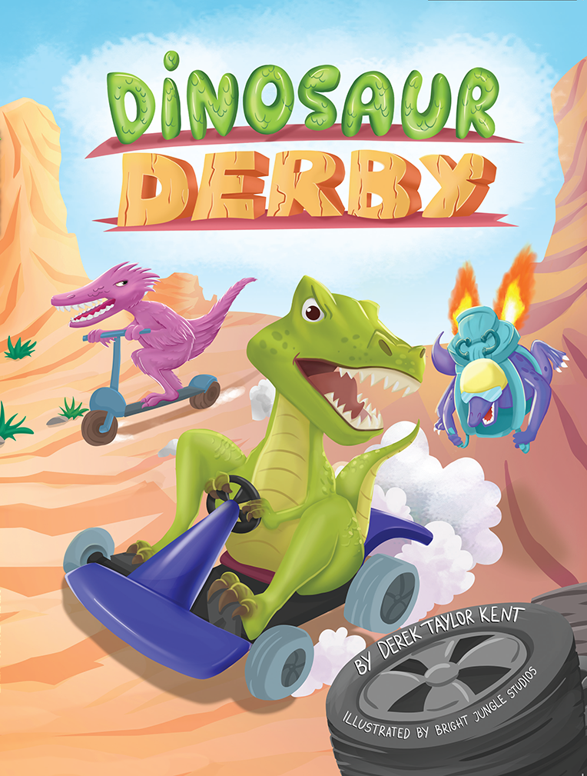

**ELD Level:** EADV **Book Title:** Dinosaur Derby **Author:** Derek Taylor Kent

**Objective:** Learn Dinosaur concepts related to biology, paleontology and evolution as well as social messages about not judging someone by their size or trying to cheat.

**Problem Statement:** This story is about a race between a wide variety of dinosaurs in different kinds of vehicles. Students will learn facts about thirteen different dinosaurs while learning a valuable lesson that size does not matter in sports if you work hard enough and don’t succumb to intimidation.

**VOCABULARY (Wide Exposure)**

|  |  |
| --- | --- |
| **Word** | **Friendly Definition/Explanation** |
| Derby | While technically it’s a type of horse race, colloquially it can mean any type of race. It’s also a type of hat. |
| Terrain | A piece of land |
| Suitor | Someone who approaches or is trying do something |
| Deflect | To bat something the opposite direction in defense |
| “Pit” = Cockpit | Where a pilot sits in a airplane |
| Groove | Dancing or moving along with music |
| Pontoon | A flat-bottomed boat |

**FIRST READ**: **Inferences/Modeled Reading Behaviors (second read students make the inferences)**

Note: Continue to do what good readers do (make predictions, model asking yourself questions, re-read, summarize, making connections).

* Page 8 - I’m thinking that the tiny dinosaurs are afraid to race against the big dinosaurs and could get hurt. I can infer that they will brave and race anyway.
* Page 17 - I’m thinking that the Tyrannosaurus is not a good sport because she tries to take the velociraptor’s tractor when her tire pops
* Page 20 - I’m thinking that because the tiny dinosaurs are lighter and more nimble, it gave them an advantage over all the different terrains they encountered so they will be able to win.

“Why” Question to Conclude: Why qualities did the tiny dinosaurs have that helped them win the race in the end?

**Dinosaur Concepts Focus**

SF with language focus: The tiny dinosaurs felt___________________________________________________ because

_______________________________________________________

Use illustration on Pages 25-26 to identify the dinosaurs they learned about.

**Q:** What kind of dinosaur has three horns? (Triceratops)

**Q**: What dinosaurs has a plated back and a spiky tail? (Stegosaurus)

**Q:** The diplodocus is the biggest dinosaur with the long neck and tail. Can you name other types of dinosaurs that look similar? (Brontosaurus, Brachiosaurus, Supersaurus – all in the Sauropod family)

**Q**: What dinosaur was had the large backbone? (Spinosaurus)

**Q**: What dinosaur had an armored pack and a club on its tail? (Anykylosaurus)

**Q**: What are the large dinosaurs that can fly? (Pterosaurs – Pterodactyls were a sub-species)

**Q:** The Velociraptor was covered in feathers because they were the early ancestors of modern birds. Can you thik of any modern birds that look a lot like dinosaurs? (Ostriches and Emus)

**Q**: Do you think that Tyrannosaurs Rex may have had feathers too? (Yes! Researchers believed they most likely had feathers or proto-feathers, which could have been used to attract mates and also make them look more frightening)

**Q:** What were the tiny dinosaurs called? (Microraptor – the flying one – and Dilong – which looked like a tiny T-Rex. “Dilong” actually means “Dinosaur” in Chinese.

**Q:** What happened to all the dinosaurs? Over 65 million years ago, a giant asteroid hit the earth that caused the climate of the Earth to change so much that almost all the dinosaurs could not survive. A few did though and continued to evolve into birds and other creatures. One of them stayed almost exactly the same as it was in dinosaur times. Can you think of wait it is? (Crocodiles and alligators)

**Q**: Why were dinosaurs so big compared to animals of today? -- Back then, there was a lot more oxygen in the air than there is today. That allowed for animals, including bugs, to be way bigger than they are today. Some bugs were the size of cars!

**CREATIVE ACTIVITY**

Dinosaurs came in all shapes, colors, and sizes. Do you think you could create your own type of dinosaur? What would you call it?

Using arts and crafts supplies, fifteen minutes and see if you can create your own, brand-new kind of dinosaur. Give it a name, too! When you are done, you will give a short presentation about your dinosaurs. Tell us what kind of terrain it lived on (mountains, plains, oceans, lakes, dessert, etc). How big was it? What did it eat?

Discover more fun facts at www.DinosaurDerby.com.