

[www.WhimsicalWorldBooks.com](http://www.WhimsicalWorldBooks.com)

**Lesson Plan for *The Little Unicorn* Book**

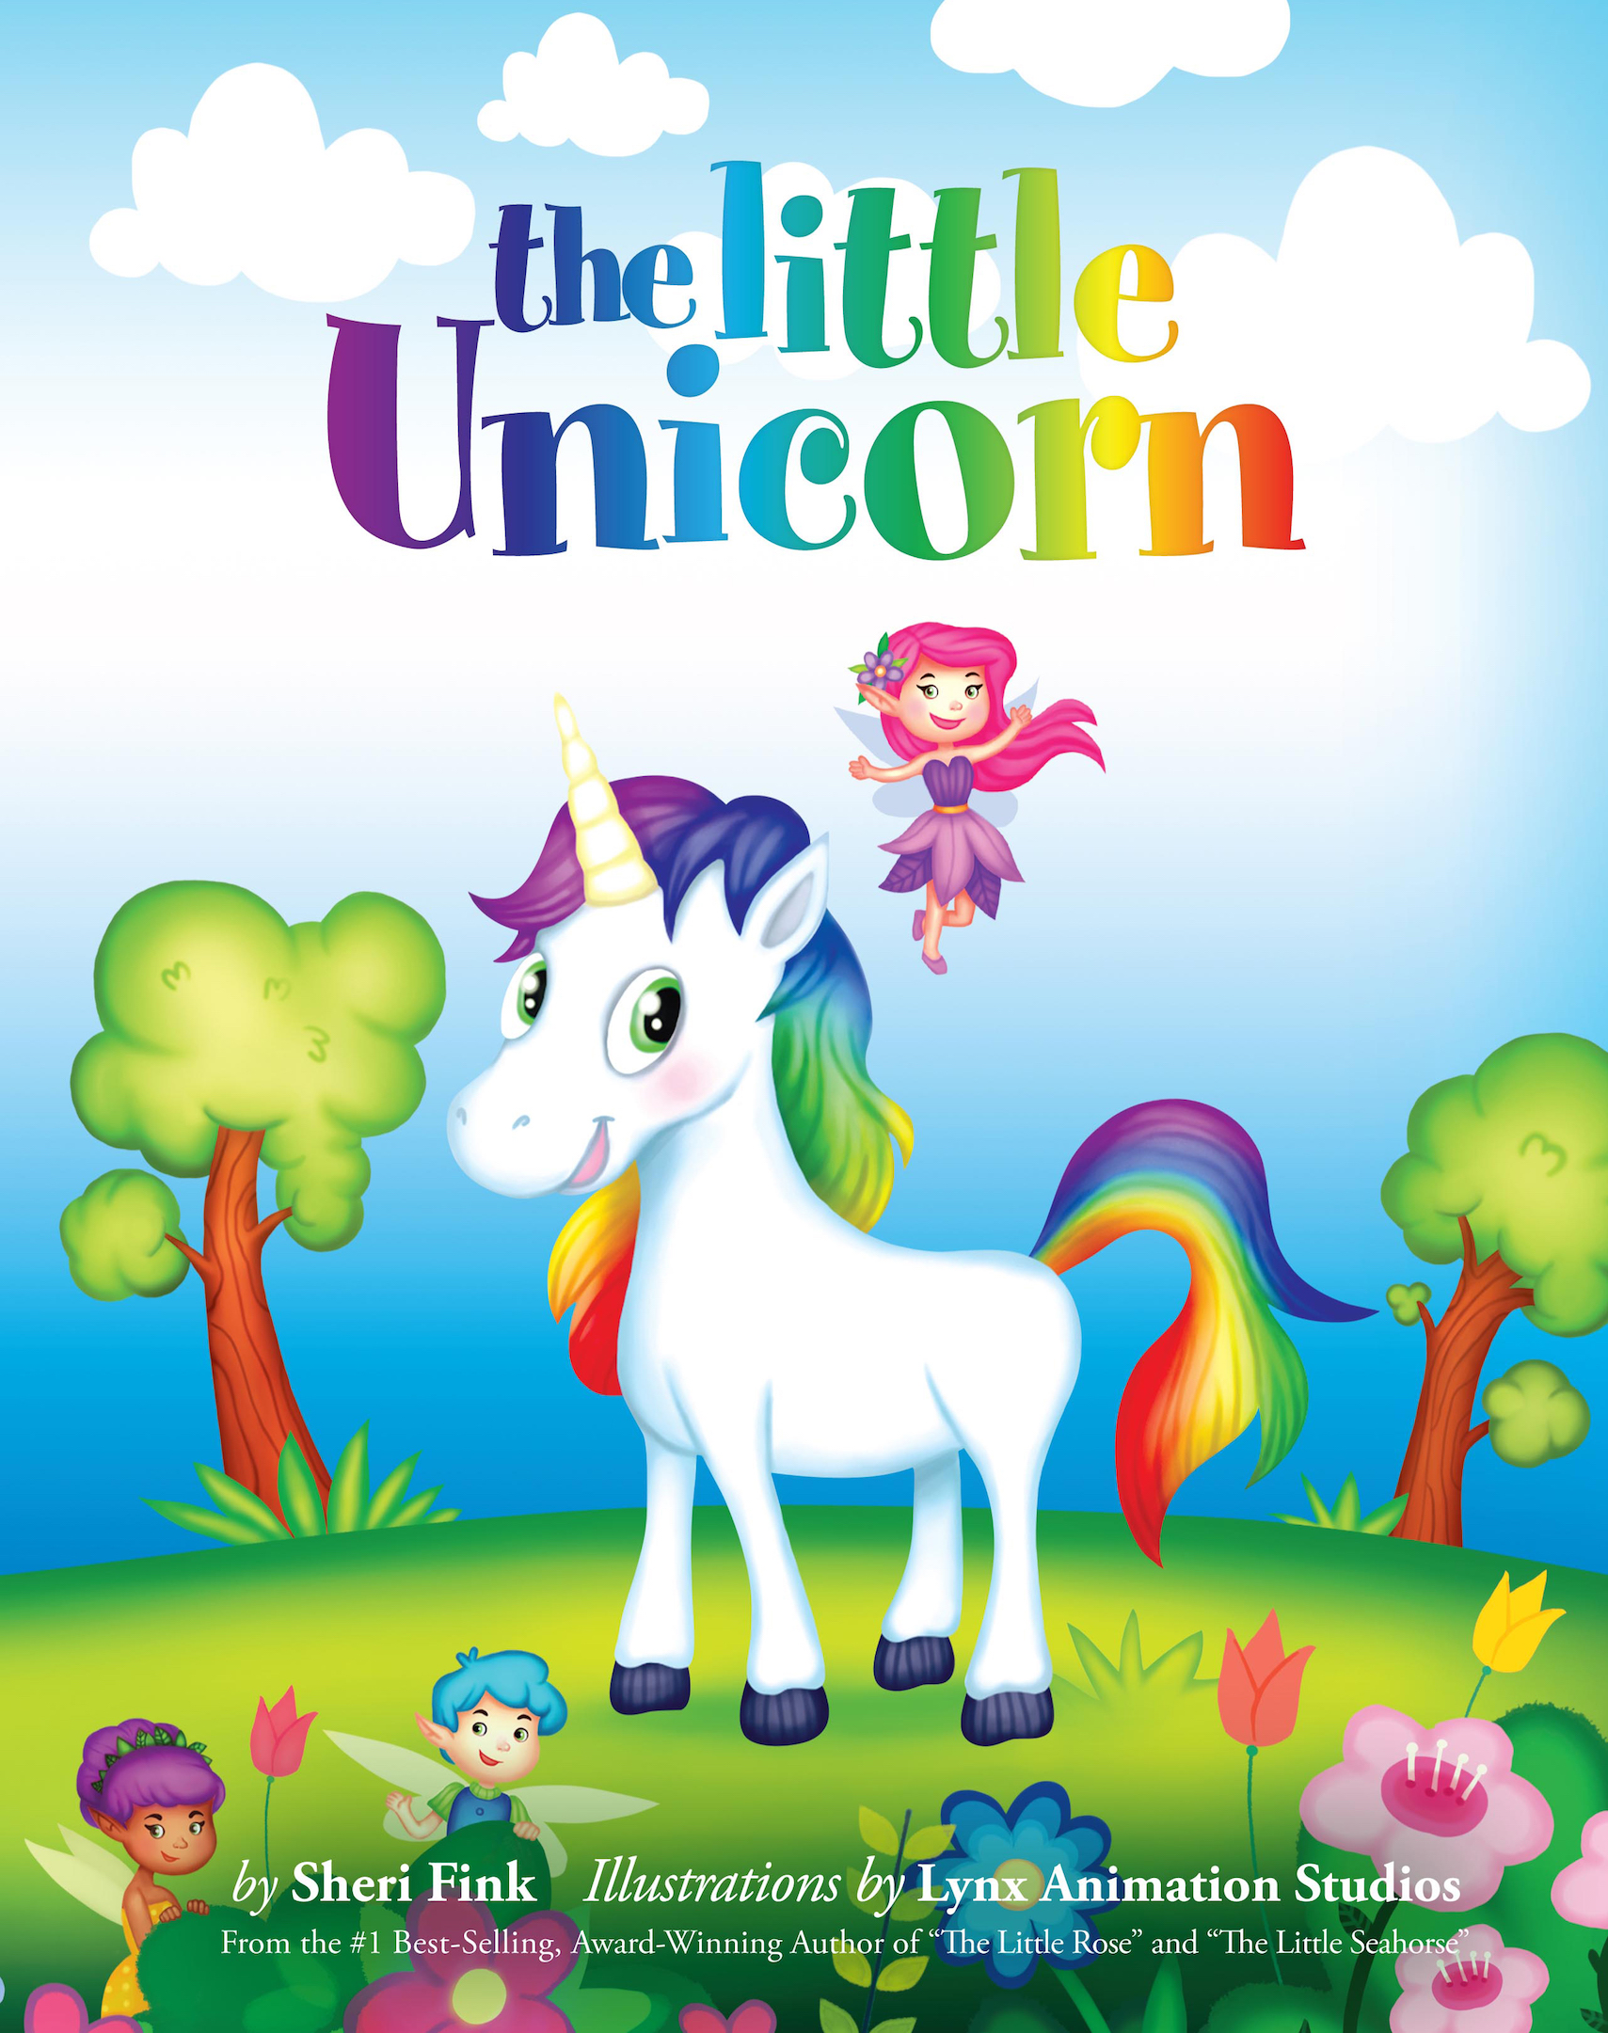**ELD Level:** EADV **Book Title:** The Little Unicorn **Author:** Sheri Fink

**Objective:** Students will participate in an interactive read aloud, answer questions, share with a partner and retell the story in a third read.

**Problem Statement:** This story is about a unicorn whose magic gives life and brightness to an enchanted forest, but when she ventures into a dark, gloomy wood, she doubts herself, loses her sparkle, and when she finds her way home the forest has lost its magic. With the help of her friend, the Pink Fairy, they set off to find her sparkle, only to discover it was within her all along.

**VOCABULARY (Wide Exposure)**

|  |  |
| --- | --- |
| **Word** | **Friendly Definition / Explanation** |
| Enchanted | Magical, filled with wonder and magic |
| Grateful | Thankful, appreciative |
| Venture | To travel, usually someplace new |
| Menacing | When something has evil intent or plans, scary |
| Dreary | Gloomy, tired, boring, featureless |
| Murky | Cloudy |
| Refuge | A safe place, seek safety |
| Radiance | Glowing light, brilliance |
| Cherish | To value something, to love something so much you want it to stay safe |

**FIRST READ**: **Inferences/Modeled Reading Behaviors (second read students make the inferences)**

Note: Continue to do what good readers do (make predictions, model asking yourself questions, re-read, summarize, making connections)

* Page 7 - I’m thinking that the Little Unicorn is curious about what’s inside the dark forest because she was told never to go there.
* Page 12-13 - I’m thinking that the Little Unicorn will try to find her sparkle, but I wonder HOW or WHERE she will be able to find it.
* Page 16 - I’m thinking that the Little Unicorn feels scared and confused because she can’t find her sparkle and then she starts to lose the color from her rainbow mane.
* The Little Unicorn felt ashamed because she didn’t think she was special without her sparkle and colors.

“Why” Question to Conclude: Why was the Little Unicorn able to find her sparkle again? Where was it hiding? How did the Pink Fairy help her?

**SECOND READ: Language Focus: Past perfect**

Q: When the Little Unicorn travels into the dark forest, she loses her sparkle and can’t find it anywhere.

SF with language focus: The Little Unicorn felt _____________________ because _____________________________________________.

Q: How was the Little Unicorn feeling before versus after meeting the Pink Fairy?

SF with language focus: She had been feeling __________________________________ but then feels ____________________________.

**SECOND READ: Common core literature standard: Describe characters and major events in a story using key details**

Prompt or Qs: Describe the Little Unicorn at the beginning of the story.

SF: At the beginning of the story, the Little Unicorn was _________________________________________________________________.

Describe the Little Unicorn in the middle of the story.

SF: In the middle of the story, the Little Unicorn was ___________________________________________________________________.

Describe the Little Unicorn at the end of the story.

SF: At the end of the story, the story, the Little Unicorn was ____________________________________________________________.

**THIRD READ: Re-tell/Respond/Join Construction of Text: Shared Writing: List feeling words from the story.**

**CREATIVE ACTIVITY**

The Little Unicorn is able to find her inner sparkle when she remembers and thinks about all the things for which she is grateful. Even though she only had one friend, the Pink Fairy, she was grateful that she had such a good friend.

Let’s see if you can make a list of ten things that you are grateful for. Whenever you’re feeling sad, you can take out this list and be reminded of everything that’s good in your life and in the world.

Example List:

1. Cookies
2. Birthday Parties
3. Holidays like Halloween and Christmas
4. My Dog/Cat/Fish
5. My Comfy Bed
6. Playing Games with my little brother/sister
7. Swimming
8. People who love me
9. Grandparents
10. Playing Soccer
11. Video Games
12. Flowers